Azure Storage Blob – Console App

Step 1: Create New Console App from Visual Studio Template
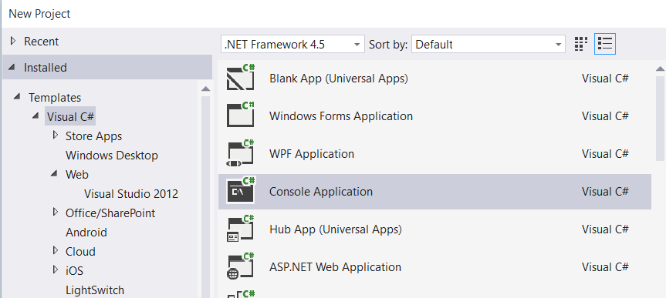

Step 2: Right click on Project name & select “Manage NuGet Packages…”
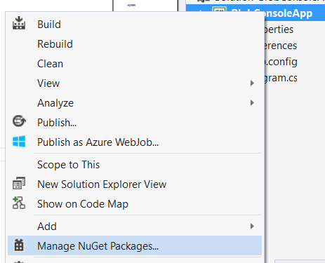

Step 3: Manage NuGet Packages dialog box will open & search for “Azure Storage”
Install “Windows Azure Storage”
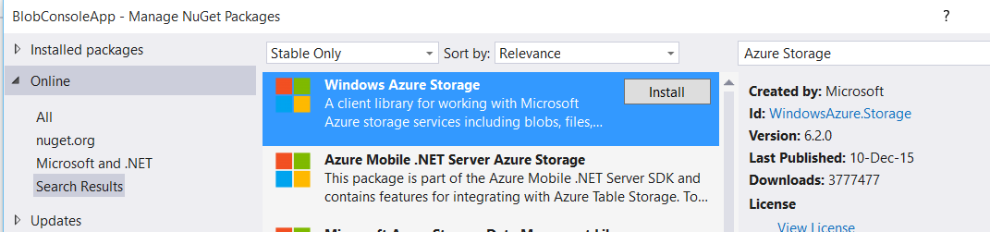

Step 4: Open app.config file, add an entry under the Configuration element, replacing the account name and key with your own storage account details:

<?xml version="1.0" encoding="utf-8" ?>
<configuration>
<startup>
<supportedRuntime version="v4.0" sku=".NETFramework,Version=v4.5" />
</startup>
<appSettings>
<add key="StorageConnectionString" value="DefaultEndpointsProtocol=https;AccountName=storageaccountname;AccountKey=storagekey" />
</appSettings>
</configuration>

Step 5: Add one reference
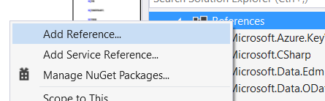

Select “System.Configuration”
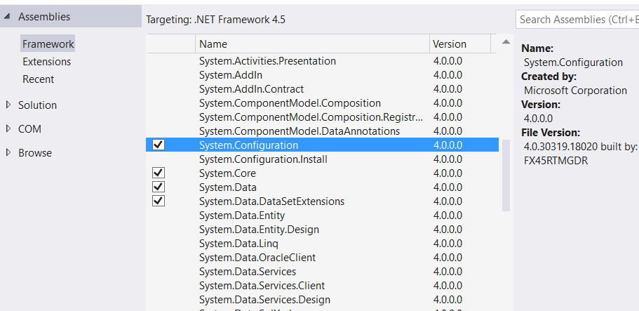

Step 6: Open Program.cs file
Add references of Azure Storage
using System.Configuration;
using Microsoft.WindowsAzure;
using Microsoft.WindowsAzure.Storage;
using Microsoft.WindowsAzure.Storage.Auth;
using Microsoft.WindowsAzure.Storage.Blob;

static void Main(string[] args)
{
//Retrieve Storage account from connection string
CloudStorageAccount storageAccount = CloudStorageAccount.Parse(ConfigurationManager.AppSettings["StorageConnectionString"]);

//Create the blob client
CloudBlobClient blobClient = storageAccount.CreateCloudBlobClient();

//Retrieve a reference to a container
CloudBlobContainer container = blobClient.GetContainerReference("storagecontainer");

//Create the container if it doesn't already exist
container.CreateIfNotExists();

//Retrieve reference to a blob named "storageblob"
CloudBlockBlob blockBlob = container.GetBlockBlobReference("BlobFile.txt");

//Create or overwrite the "storageblob" blob with contents from a local file
using (var filestream = System.IO.File.OpenRead(@"C:\azure\BlobFile.txt"))
{
blockBlob.UploadFromStream(filestream);
}
}

